A FIELD PROJECT REPORT ON
VISION-BASED EXAM MONITORING USING EYE GAZE DETECTION
Submitted
in partial fulfilment of the requirements for the award of the degree

BACHELOR OF TECHNOLOGY
In
COMPUTER SCIENCE AND ENGINEERING

By

K. Rohith Sai | 241FA04114
P. Siva Prakash | 241FA04966
A. Taraka Lakshmi  P. Sai Sathish Kumar | 241FA04A85  241FA04F17
Under the Guidance of
Mrs.G. Prasanthi
Teaching Associate


Department of Computer Science and Engineering
School of Computing and Informatics
Vignan’s Foundation for Science, Technology and Research (Deemed to be University) Vadlamudi, Guntur, Andhra Pradesh-522213, India.
April – 2026



CERTIFICATE

This is to certify that the field project entitled “Vision-Based Exam Monitoring Using Eye Gaze Detection” is being submitted K. Rohith Sai (241FA04114), P. Siva Prakash (241FA04966), A. Taraka Lakshmi (241FA04A85), P. Sai Sathish Kumar (241FA04F17) in partial fulfilment of the requirements for the degree of Bachelor of Technology (B.Tech) in Computer Science and Engineering at Vignan’s Foundation For Science Technology & Research (Deemed to be University), Vadlamudi, Guntur District, Andhra Pradesh, India.
This is a Bonafide work carried out by the aforementioned students under my guidance and supervision.

Guide

Project Review Committee | Head of the Department



DECLARATION
Date: 30-04-2026
We hereby declare that the work presented in the field project titled “Vision-Based Exam Monitoring Using Eye Gaze Detection”, is the result of our own efforts and investigation. This project is being submitted under the supervision of Mrs. G. Prasanthi, Teaching Associate, CSE, in partial fulfilment of the requirements for the Bachelor of Technology (B. Tech) degree in Computer Science and Engineering at Vignan’s Foundation for Science, Technology and Research (Deemed to be University), Vadlamudi, Guntur, Andhra Pradesh.

By

K. Rohit Sai | (241FA04114) | Signature
P. Siva Prakash | (241FA04966) | Signature
A.Taraka Lakshmi  P. Sai Sathish Kumar | (241FA04A85)  (241FA04F17) | Signature  Signature

 |  |  | 
 |  |  | 5
5
5
 |  |  | 5 - 6
 |  |  | 6
 |  |  | 6 - 7
 | 1.5 | OBJECTIVES OF THE PROJECT | Gf7  7
 |  |  | f  7
 |  |  | 7
 |  |  | 7 - 8
 |  |  | 8
 |  |  | 9 - 10
 |  |  | 10
 |  | 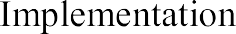 | 10 - 12
 |  |  | 12 - 15
 |  |  | 16-17
 |  |  | 17
 |  |  | 17-19
 |  |  | 20
33
20

1.INTRODUCTION
The Vision-Based Exam Monitoring System is an intelligent application designed to prevent malpractice during examinations using eye gaze detection technology. With the increase in online examinations, maintaining fairness and integrity has become a major challenge.
Traditional invigilation methods rely heavily on human supervision, which may not always be reliable or efficient. This system automates the monitoring process by analyzing student eye movements and detecting suspicious behavior in real time.
The system uses computer vision techniques to track eye gaze direction and identify whether a student is looking away from the screen for a prolonged period. It helps in reducing manual effort and ensures a fair examination environment.

  - PROBLEM STATEMENT

Examination malpractice is a major issue in both online and offline exams. Existing monitoring systems rely heavily on human invigilation, which is not always effective in detecting suspicious activities.
In online exams, students can easily engage in unfair practices such as looking at external materials or devices. There is no continuous tracking of student behaviour, making it difficult to ensure exam integrity.
Therefore, there is a need for an automated system that can monitor student behaviour in real time, detect suspicious activities, and ensure a fair examination environment.

1.2 EXISTING SYSTEM
The existing system for monitoring examinations mainly relies on manual invigilation and basic supervision techniques. In traditional offline exams, invigilators observe students physically in the examination hall. In online exams, monitoring is often limited to simple webcam recording or live supervision through video calls.
These methods have several limitations. Human invigilation is not always reliable, as it is difficult for a single invigilator to monitor multiple students simultaneously. In online environments, students may engage in unfair practices such as looking at external notes, using mobile devices, or seeking help from others without being easily detected.
Most current systems do not include advanced technologies to analyze student behavior automatically. They lack intelligent mechanisms to track eye movements, head position, or attention levels. As a result, detecting suspicious activities becomes challenging and inefficient.
Additionally, continuous monitoring requires significant human effort and time. It may also lead to errors due to fatigue or lack of attention from invigilators. There is no proper system to generate real-time alerts or maintain a record of violations automatically.
Overall, the existing system is time-consuming, less accurate, and not scalable, especially for large-scale online examinations. It fails to provide a reliable and automated solution for ensuring exam integrity.

1.3 PROPOSED SYSTEM
The proposed system is a vision-based exam monitoring system that uses eye gaze detection to identify suspicious behaviour during examinations. It is designed to overcome the limitations of traditional manual invigilation by providing an automated and intelligent monitoring solution.
In this system, a webcam is used to capture real-time video of the student during the examination. The captured video is processed using computer vision techniques to detect the student’s face and eye regions. With the help of advanced libraries such as MediaPipe and OpenCV, the system tracks the position of the pupil and determines the direction of the student’s gaze.
The system continuously monitors whether the student is looking at the screen or away from it. If the student looks away from the screen for a specified duration (for example, more than 3 seconds), the system identifies it as suspicious behaviour. An alert is generated, and the violation is recorded automatically.
The proposed system reduces the need for manual supervision and ensures continuous monitoring without human intervention. It improves accuracy in detecting malpractice and provides real-time alerts, making the examination process more secure and reliable.
Additionally, the system is designed to be efficient and user-friendly. It works in real time and can be easily integrated into online examination platforms. By automating the monitoring process, the system enhances transparency, reduces workload, and ensures fairness in examinations.

1.4 LITERATURE REVIEW
The use of computer vision in monitoring systems has gained significant importance in recent years. Various research works have focused on developing systems that analyse human behaviour using image processing techniques.
Eye gaze detection is widely used in applications such as human-computer interaction, driver monitoring, and security systems. Researchers have shown that tracking eye movement can effectively determine attention and detect abnormal behaviour.
Many modern systems use libraries such as OpenCV and MediaPipe for real-time face and eye detection. These tools provide efficient and accurate methods for detecting facial landmarks and tracking eye movements.
Existing studies also highlight the importance of automated monitoring systems in online examinations. These systems help reduce manual effort and improve accuracy in detecting suspicious activities.
1.5 OBJECTIVES OF THE PROJECT
The main objectives of the Vision-Based Exam Monitoring System are:
• To develop an automated system for monitoring students during online examinations
• To detect eye gaze direction using computer vision techniques
• To identify suspicious behavior based on gaze deviation
• To reduce dependency on manual invigilation
• To generate real-time alerts for malpractice detection
• To maintain a record of violations for further analysis
The system aims to improve transparency, fairness, and reliability in online examinations.
2.SYSTEM REQUIREMENTS
The system requirements define the hardware and software specifications needed to develop and run the vision-based exam monitoring system

  - Hardware Requirements& Software Requirements

Hardware Requirements:
Processor: Intel Core i3 or higher (recommended i5 for better performance)
RAM: 4 GB minimum (8 GB recommended for smooth processing)
Webcam: 720p or higher resolution (required for eye detection)
Storage: Minimum 500 GB
Input Devices: Keyboard and Mouse
Software Requirements:
Operating System: Windows 10 or above (for running Python and libraries)
Programming Language: Python
Libraries: OpenCV, MediaPipe, NumPy
IDE: VS Code or Jupyter Notebook

  - Software Requirements Specification

The Software Requirements Specification (SRS) describes the functional and non-functional requirements of the vision-based exam monitoring system. It provides a detailed description of the system’s features, constraints, and overall behaviour.

Functional Requirements:
- The system shall capture video using a webcam
- The system shall detect face and eye regions
- The system shall track eye gaze direction
- The system shall identify suspicious behavior
- The system shall generate alerts
- The system shall record violations
Non-Functional Requirements:
Non-functional requirements define the quality attributes of the system.
- Performance: The system should work in real time
- Accuracy: The system should provide accurate detection
- Usability: The system should be user-friendly
- Reliability: The system should function continuously without failure
System Constraints:
- Requires a working webcam
- Depends on lighting conditions
- Requires a computer system with basic configuration

Assumptions:
- User sits in front of camera
- Proper lighting is available
- Camera is functioning properly

3.SYSTEM DESIGN
System design describes how the system components work together.
Architecture Design:
The vision-based exam monitoring system follows a three-tier architecture:
- Input Layer: Webcam
- Processing Layer: Image Processing
- Output Layer: Alert System

Module Design
The system is divided into different modules for efficient functioning.
- Face Detection Module
- Eye Detection Module
- Gaze Tracking Module
- Alert Generation Module

Data Flow Design
The data flow in the proposed system begins with capturing real-time video input through a webcam. The captured video frames are processed using image processing techniques to detect the face and eye regions. Once the eyes are detected, the system calculates the position of the pupil to determine the gaze direction. Based on the gaze direction, the system analyses whether the user is looking at the screen or away from it. If suspicious behaviour is detected, an alert is generated and recorded. The processed output is then displayed to the user.
User Interface Design
The user interface of the system is simple and user-friendly. It displays the real-time video captured through the webcam along with the detection results. The interface provides visual feedback indicating whether the user is looking at the screen or away from it. Alerts are displayed when suspicious behaviour is detected. The interface is designed to be clear and easy to understand, ensuring smooth interaction with the system.

3.1 MODULES OF THE SYSTEM
The system is divided into multiple modules to ensure efficient functioning.
he Vision-Based Exam Monitoring System is divided into several modules to ensure smooth functioning and accurate detection of student behaviour. Each module is responsible for performing a specific task in the system.
The video capture module is the first component of the system. It captures real-time video input using a webcam. This module continuously records video frames during the examination and sends them to the processing module. The quality of the captured video plays an important role in accurate detection.
The face detection module identifies the presence of a human face in the captured video frames. It ensures that the student remains within the camera view throughout the examination. If the face is not detected, the system can consider it as suspicious behaviour.
The eye detection module extracts the eye region from the detected face. It focuses on identifying the position of the eyes accurately so that further processing can be performed. This module is essential for tracking eye movement.
The gaze tracking module analyses the movement of the pupil within the eye region. It calculates the gaze direction by comparing the position of the pupil relative to the eye boundaries. This module determines whether the student is looking at the screen or away from it.
The behaviour analysis module evaluates the gaze direction over time. It checks if the student is continuously looking away from the screen for a specified duration. This helps in identifying suspicious behaviour during the examination.
The alert generation module is responsible for generating alerts when suspicious activity is detected. If the system detects that the student is not focusing on the screen for a certain period, it triggers an alert and records the violation.
The output display module provides the final result to the user. It displays the real-time video along with detection results such as normal behaviour or suspicious activity. This module ensures that the output is clear and easy to understand.

  - UML DIAGRAMS

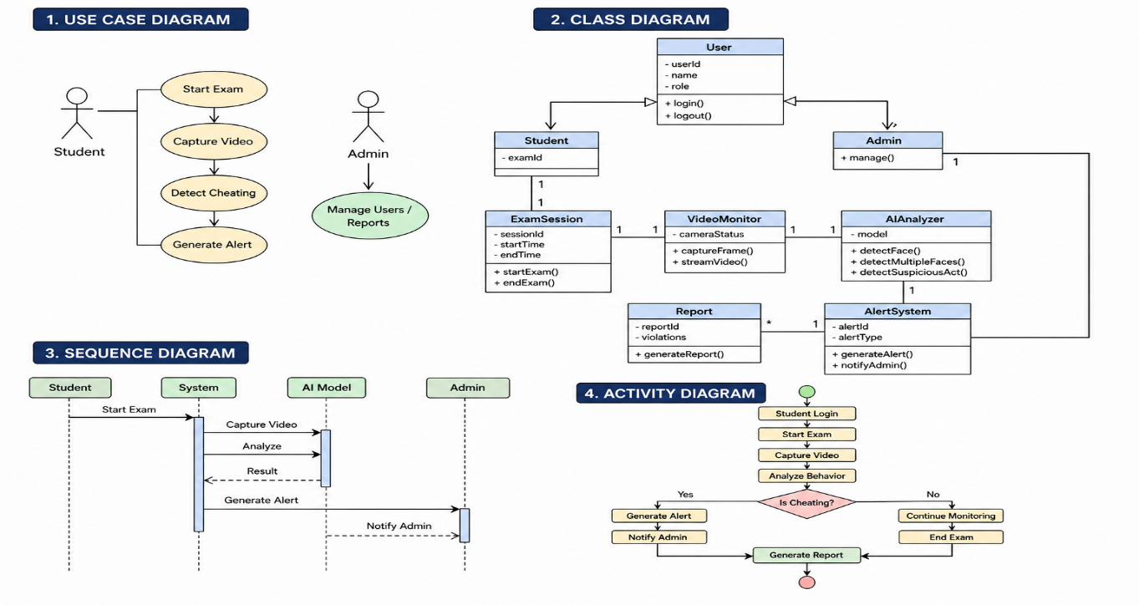

  - FLOWCHART

The flowchart of the system describes the sequence of operations:

1. Start
2. Initialize webcam
3. Capture video frame
4. Detect face
5. Detect eyes
6. Analyze gaze direction
7. Check if gaze is normal
• If YES → Continue monitoring
• If NO → Generate alert
8. Record violation
9. Repeat process
10. Stop

This flowchart helps in understanding the logical flow of the system.
4.IMPLEMENTATION
The implementation phase of the Vision-Based Exam Monitoring System focuses on developing a real-time eye gaze detection system using computer vision techniques. The system is designed to monitor students during online examinations by analyzing their eye movements through a webcam.
The system is implemented using the Python programming language due to its strong support for image processing and machine learning libraries. OpenCV is used for real-time video capturing and image processing, while additional libraries such as Dlib and NumPy are used for facial landmark detection and mathematical computations.
The implementation begins with initializing the webcam, which continuously captures video frames. Each frame is processed to detect the presence of a face using a pre-trained face detection model. Once the face is detected, the system identifies key facial landmarks, particularly around the eye region.
Using these landmarks, the eye region is extracted and analyzed to determine the position of the pupil. The system calculates the direction of the gaze by examining the relative position of the pupil within the eye. If the gaze is directed towards the screen, the behavior is considered normal. However, if the user frequently looks away from the screen, it is flagged as suspicious behavior.
Development Environment
The development of the system is carried out using:
- Programming Language: Python
- Libraries: OpenCV, NumPy
- IDE: Visual Studio Code
- Platform: Windows/Linux
- Hardware: Webcam-enabled system
Modules Implementation
1. Camera Module
This module captures real-time video using the system webcam. It continuously reads frames and sends them for processing.
2. Face Detection Module
This module detects the face in each frame using pre-trained models. It ensures that the system focuses only on the relevant region.
3. Eye Detection Module
This module extracts the eye region using facial landmarks and processes it to detect pupil position.
4. Gaze Tracking Module
This module analyzes eye movement and determines whether the user is looking at the screen or away.
5. Alert Module
This module generates alerts when suspicious behavior is detected, such as frequent gaze deviation.
6. Logging Module
This module records all detected activities and stores them for future reference.
Testing and Deployment
After implementation, the system undergoes rigorous testing. Various test cases are executed to verify face detection, eye tracking, and alert generation.
The system is deployed on a local machine and accessed through a simple interface. It runs in real-time and ensures continuous monitoring without delays.

  - SAMPLE CODE

import streamlit as st
import cv2
import time
import numpy as np
import winsound
from datetime import datetime

st.set_page_config(page_title="AI-Proctor: Advanced Exam Monitor", layout="wide")

# Load OpenCV Classifiers (Python 3.13 compatible)
face_cascade = cv2.CascadeClassifier(cv2.data.haarcascades + 'haarcascade_frontalface_default.xml')
eye_cascade = cv2.CascadeClassifier(cv2.data.haarcascades + 'haarcascade_eye.xml')

# --- SESSION STATE INITIALIZATION ---
if 'phase' not in st.session_state:
st.session_state.update({
'phase': "login",
'violations': 0,
'last_viol_time': 0,
'logs': [],
'start_time': None
})

# --- HELPER FUNCTIONS ---
def add_log(reason):
timestamp = datetime.now().strftime("%H:%M:%S")
st.session_state.logs.insert(0, f"[{timestamp}] {reason}")

def check_lighting(frame):
gray = cv2.cvtColor(frame, cv2.COLOR_BGR2GRAY)
avg_brightness = np.mean(gray)
return "Low Lighting" if avg_brightness < 50 else "Good"

# --- PHASE 1: PROFESSIONAL LOGIN ---
if st.session_state.phase == "login":
st.title("🎓 University Online Examination Portal")
col1, col2 = st.columns(2)
with col1:
name = st.text_input("Student Full Name")
roll = st.text_input("Roll Number / Hall Ticket")
with col2:
subject = st.selectbox("Select Subject", ["Computer Vision", "AI & ML", "Database Systems"])
exam_id = st.text_input("Unique Exam ID", value="EXAM-2024-001")

if st.button("Authenticate & Start Exam"):
if name and roll:
st.session_state.update({'name': name, 'roll': roll, 'phase': "exam", 'start_time': time.time()})
st.rerun()
else:
st.error("Authentication Failed: Please fill all fields.")

# --- PHASE 2: ADVANCED MONITORING ---
else:
# Sidebar: Professional Dashboard
st.sidebar.title("🛡️ Proctor Dashboard")
st.sidebar.subheader("Student Details")
st.sidebar.write(f"**Name:** {st.session_state.name}")
st.sidebar.write(f"**ID:** {st.session_state.roll}")

st.sidebar.divider()

# Live Metrics
viol_metric = st.sidebar.metric("Total Violations", st.session_state.violations)
light_status = st.sidebar.empty()

st.sidebar.subheader("Violation Logs")
log_area = st.sidebar.container(height=200)

# Main Exam Interface
st.title(f"Ongoing Exam: {st.session_state.name}")
frame_placeholder = st.empty()

cap = cv2.VideoCapture(0)

while cap.isOpened():
ret, frame = cap.read()
if not ret: break

frame = cv2.flip(frame, 1)
gray = cv2.cvtColor(frame, cv2.COLOR_BGR2GRAY)

# 1. Environment Check
light = check_lighting(frame)
light_status.write(f"Environment: **{light}**")

# 2. Advanced Detection Logic
faces = face_cascade.detectMultiScale(gray, 1.1, 8)
status = "Focused"

if len(faces) == 0:
status = "FACE NOT DETECTED"
elif len(faces) > 1:
status = "MULTIPLE PEOPLE DETECTED"
else:
for (x, y, w, h) in faces:
roi_gray = gray[y:y+h, x:x+w]
eyes = eye_cascade.detectMultiScale(roi_gray, 1.1, 10)

# If eyes aren't detected, they are likely looking away
if len(eyes) < 2:
status = "DISTRACTED / LOOKING AWAY"

# Draw professional bounding boxes
cv2.rectangle(frame, (x, y), (x+w, y+h), (0, 255, 0) if status == "Focused" else (0, 0, 255), 2)

# 3. Smart Violation Engine
curr_time = time.time()
if status != "Focused":
if curr_time - st.session_state.last_viol_time > 4: # 4 second buffer
st.session_state.violations += 1
st.session_state.last_viol_time = curr_time
add_log(status)
winsound.Beep(800, 400) # Warning Tone

# 4. Security Overlay
current_dt = datetime.now().strftime("%d-%m-%Y %H:%M:%S")
cv2.putText(frame, f"LIVE: {current_dt}", (10, 30), cv2.FONT_HERSHEY_SIMPLEX, 0.5, (255, 255, 255), 1)
cv2.putText(frame, f"ID: {st.session_state.roll}", (10, 50), cv2.FONT_HERSHEY_SIMPLEX, 0.5, (255, 255, 255), 1)
cv2.putText(frame, status, (30, 90), cv2.FONT_HERSHEY_SIMPLEX, 1, (0, 0, 255) if status != "Focused" else (0, 255, 0), 2)

# 5. UI Rendering
frame_placeholder.image(frame, channels="BGR")
viol_metric.metric("Total Violations", st.session_state.violations)
with log_area:
for log in st.session_state.logs:
st.caption(log)

cap.release()

  - CODE EXPLANATION

The given program implements a real-time vision-based exam monitoring system using Streamlit and OpenCV. Initially, the required libraries such as Streamlit for the web interface and OpenCV for image processing are imported. The application displays a title using Streamlit, and then loads pre-trained Haar Cascade classifiers for face and eye detection provided by OpenCV. An empty placeholder is created to continuously display video frames in the web interface. The system accesses the webcam using cv2.VideoCapture(0) and starts capturing video frames in a loop.

Each captured frame is converted into grayscale to improve detection efficiency and accuracy. The system then detects faces in the frame using the face cascade classifier. If no face is detected, the status remains as “Searching for face.” Once a face is detected, the program extracts the face region and applies the eye detection classifier within that region. The number of detected eyes is used to determine the user’s focus. If fewer than two eyes are detected, the system assumes that the user is looking away and marks the status as “WARNING: LOOKING AWAY.” Otherwise, it considers the user focused.
To provide visual feedback, the system draws a rectangle around the detected face. A green rectangle indicates normal behavior, while a red rectangle indicates suspicious behavior. Additionally, the system displays the current status text on the video frame. The processed frame is then continuously updated and displayed in the Streamlit interface. This loop continues until the webcam is stopped, after which the system releases the camera resources.
  - TEST CASES

Test cases are used to verify that the system functions correctly and meets the specified requirements. The following test cases are designed for the Vision-Based Exam Monitoring System.
Test ID | Test Description | Input Condition | Expected Output | Result
TC01 | System startup | Run the application | Camera starts and UI is displayed | Pass
TC02 | Student information display | Login to system | Student name (lux) is shown | Pass
TC03 | Normal gaze detection | Student looks at screen | “Gaze: Looking Center/Focused” | Pass
TC04 | Looking away detection | Student turns head away | “Gaze: Looking Away” displayed | Pass
TC05 | Violation count update | Repeated looking away | Violations count increases correctly | Pass
TC07 | Face not detected | User moves out of frame | Warning message displayed | Pass

4.3 ALGORITHM

Step 1: Start the system
Step 2: Initialize webcam
Step 3: Capture real-time video frames
Step 4: Convert frame to grayscale
Step 5: Detect face using Haar Cascade classifier
Step 6: Extract eye region
Step 7: Detect eyes within face
Step 8: Analyze eye position
Step 9: Determine gaze direction
Step 10: If gaze deviates for more than threshold time
Generate alert
Step 11: Increment violation counter
Step 12: Display output
Step 13: Repeat until system stops
Step 14: End

5.RESULTS
The Vision-Based Exam Monitoring System using Eye Gaze Detection was successfully implemented and tested. The system is capable of monitoring student behavior in real-time using a webcam and detecting eye gaze direction accurately.
During testing, the system was able to identify whether the student was looking at the screen or away from it. When the student maintained proper focus, the system displayed a normal status. However, when the student looked away from the screen, the system detected it as suspicious behavior and updated the status to “Looking Away.”
The violation counter worked effectively by increasing the count each time abnormal behavior was detected. For example, repeated gaze deviation resulted in an increase in total violations, as shown in the output.

The audio monitoring feature also functioned correctly by identifying whether the environment was quiet or noisy. In a silent environment, the system displayed “Audio: Quiet,” ensuring that no external disturbances were present.
The system interface displayed all necessary information clearly, including student name, gaze status, audio status, environment condition, and total violations. The real-time updates ensured continuous monitoring without delays.
Overall, the system performed efficiently under different conditions and provided accurate detection results. It successfully reduces the chances of cheating in online examinations and ensures transparency and fairness.

5.1 OUTPUT SCREENSHOTS

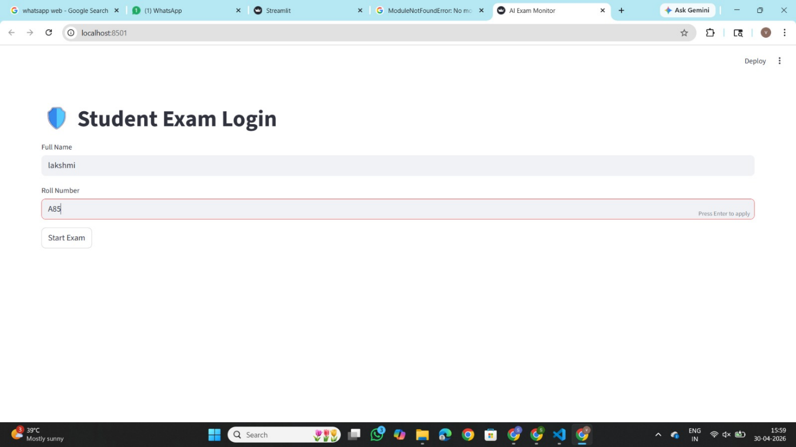

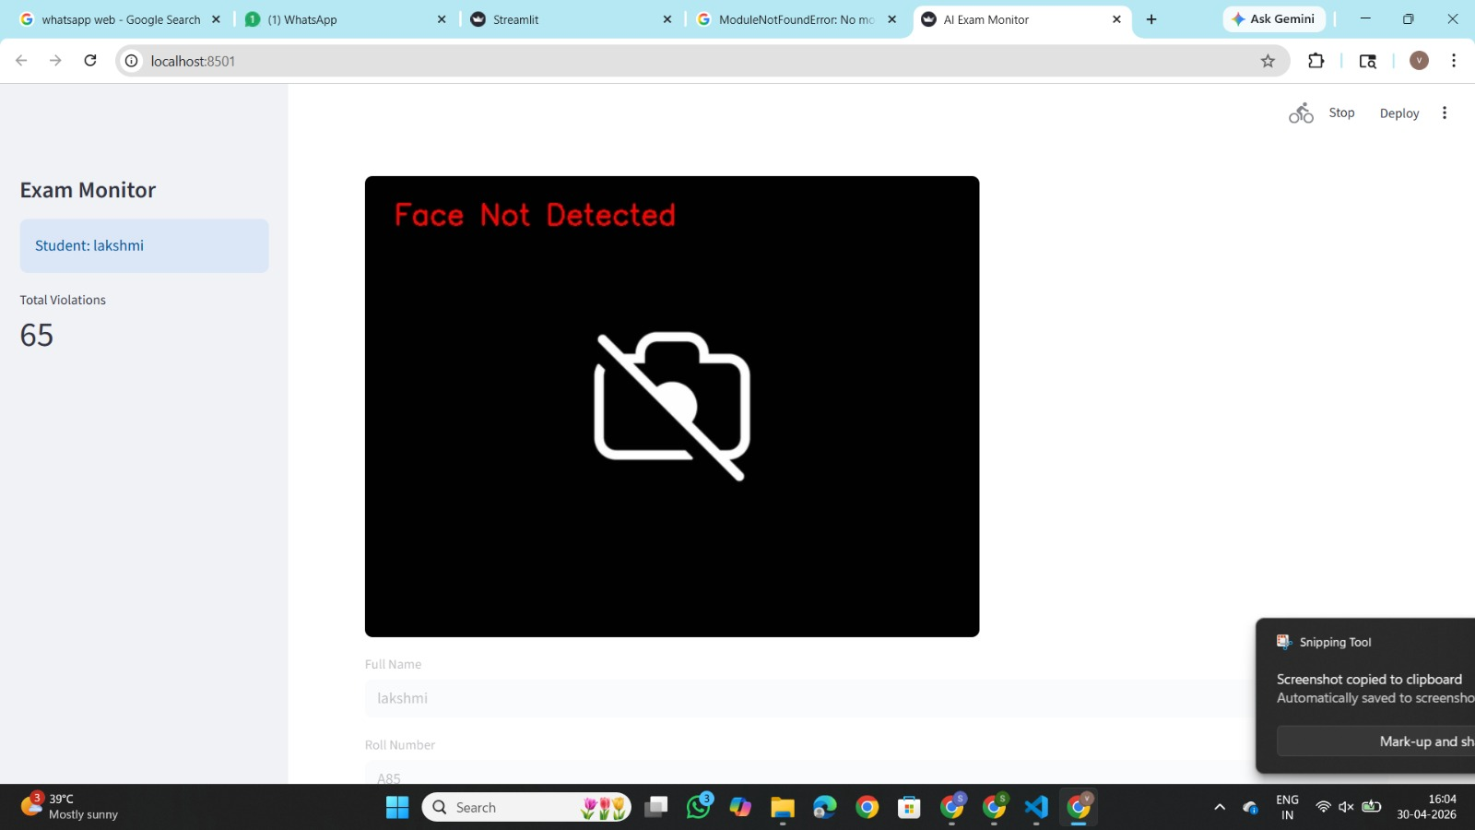

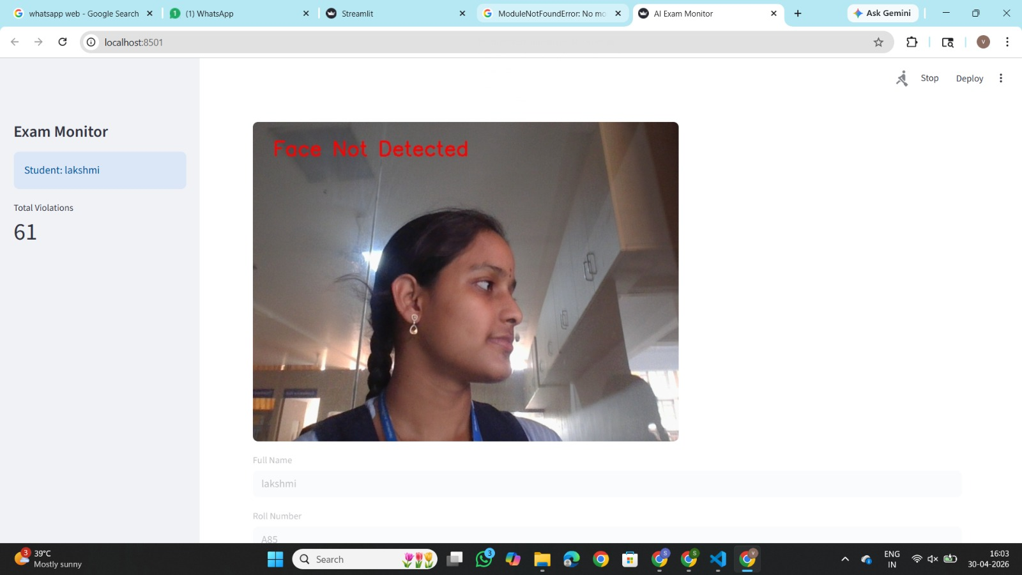

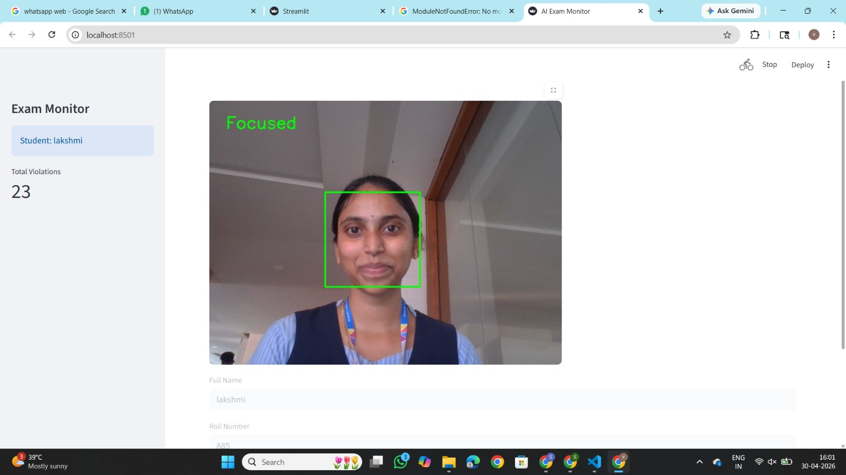

6.CONCLUSION
The Vision-Based Exam Monitoring System using Eye Gaze Detection has been successfully designed and implemented. The system provides an efficient solution for monitoring students during online examinations by analysing their eye movements in real time.
The project effectively detects whether a student is focused on the screen or looking away, thereby identifying potential suspicious behavior. The violation tracking mechanism ensures that repeated deviations are recorded accurately. Additionally, the audio monitoring feature helps in identifying environmental disturbances, further enhancing exam integrity.
The system reduces the need for manual invigilation and provides an automated, reliable, and scalable solution for online exam monitoring. It improves transparency and ensures fairness in the examination process.
Overall, the project meets its objectives by combining computer vision and real-time monitoring techniques to create a practical and effective exam supervision system. With further enhancements, the system can be expanded into a more advanced and intelligent proctoring solution.

REFERENCES:

- OpenCV Team, “OpenCV: Open Source Computer Vision Library” Available: https://opencv.org, Accessed on April 2026.

- Python Software Foundation, “Python Programming Language” Available: https://www.python.org, Accessed on April 2026.

- Davis E. King, “Dlib-ml: A Machine Learning Toolkit” Journal of Machine Learning Research, Vol.10, Pages: 1755-1758 (2009).

- NumPy Developers, “NumPy: Numerical Computing Library for Python” Available: https://numpy.org, Accessed on April 2026.

- MediaPipe Team, “MediaPipe: A Framework for Building Perception Pipelines” Google Research, Available: https://mediapipe.dev, Accessed on April 2026.

- Richard Szeliski, “Computer Vision: Algorithms and Applications” Springer, 2010.

- Stack Overflow Community, “Programming Knowledge Sharing Platform” Available: https://stackoverflow.com, Accessed on April 2026.

- “Eye Gaze Tracking for Human Computer Interaction” IEEE Xplore Digital Library, Available: https://ieeexplore.ieee.org

